EXP 11
Aim: To implement a Hyperledger Fabric network, deploy chaincode, and perform asset creation, querying, and transfer operations.

Theory:

Introduction to Hyperledger Fabric
Hyperledger Fabric is an open-source, permissioned blockchain platform designed for enterprise use. Unlike public blockchains, it allows only authorized participants to join the network, ensuring privacy, scalability, and security. It follows a modular architecture where components such as consensus, membership services, and smart contracts can be customized.

Fabric Network Architecture
A Hyperledger Fabric network consists of the following components:
- Peers: Nodes that maintain the ledger and execute transactions
- Orderers: Responsible for ordering transactions and creating blocks
- Organizations: Groups of participants in the network
- Channels: Private sub-networks for confidential transactions
- Certificate Authority (CA): Issues digital identities to users
Each participant interacts with the network through secure cryptographic identities.

Prerequitise
- Check if WSL is Installed
Open PowerShell (Run as Administrator) and run:

wsl --list --verbose

If it shows no distributions, you must install Ubuntu.

Install Ubuntu for WSL

Run this command in PowerShell (Admin):

wsl --install -d Ubuntu

This installs:
  - Ubuntu
  - WSL2 kernel
The installation may take a few minutes.

Restart Your Computer
After installation finishes, restart your PC. Open Ubuntu: Open Start Menu → Ubuntu It will ask you to create:
Username Password
Now Ubuntu is ready.

Implementation

Step 1 — Update the system

code :
sudo apt update sudo apt upgrade -y
Explain: apt update refreshes the package index — it tells your system what versions of
software are available. apt upgrade installs the newer versions. Fabric's dependencies (Docker, curl, git) can fail or behave unexpectedly on outdated system libraries. Always do this first on a fresh machine.

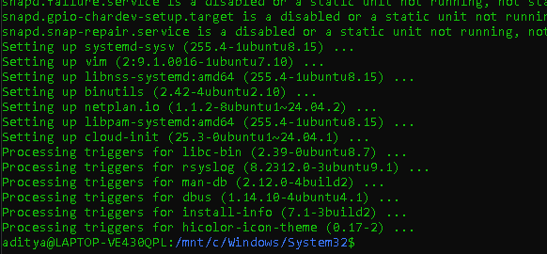

Step 2 — Verify prerequisites

code :
sudo apt install jq curl git nodejs npm -y node -v
npm -v
git --version docker --version docker ps
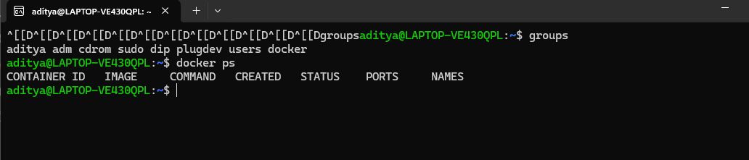

Explain: Fabric requires Docker (to run peer/orderer containers), Git (to clone the repo), and Node.js + npm (to build JavaScript chaincode). Running docker ps with no output confirms the Docker daemon is running and your user can access it. If docker ps requires sudo, you need to add your user to the docker group.

Step 3 — Clone fabric-samples

code :
git clone https://github.com/hyperledger/fabric-samples

cd fabric-samples
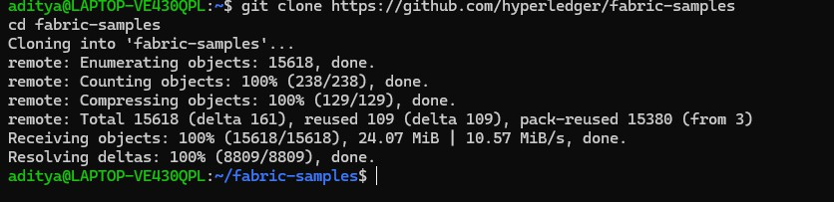

Explain: fabric-samples is the official repository containing the test-network scripts,
ready-made chaincode examples (including asset-transfer-basic), and configuration files.
Everything else in this guide runs from inside this directory.

Step 4 — Download the install script and run it

code :
curl -sSLO https://raw.githubusercontent.com/hyperledger/fabric/main/scripts/install-fabric.sh chmod +x install-fabric.sh
./install-fabric.sh docker samples binary
./install-fabric.sh docker

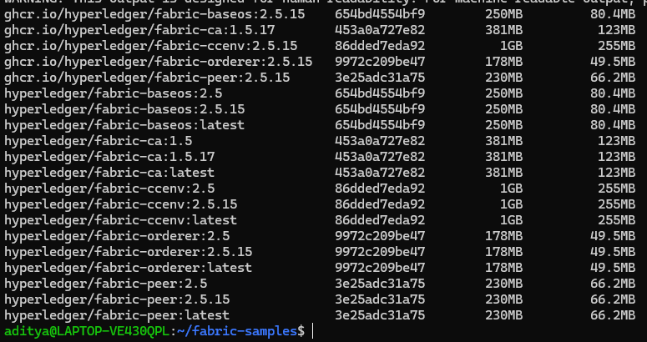

Explain: This one script does three things simultaneously. docker pulls all Fabric Docker images — fabric-peer, fabric-orderer, fabric-ccenv, fabric-baseos, fabric-ca, and critically
fabric-nodeenv (needed to build Node.js chaincode). binary downloads the CLI tools — peer, configtxgen, configtxlator — into ~/fabric-samples/bin. samples ensures the chaincode sample directories are present. Without fabric-nodeenv, chaincode deployment fails later.

Step 5 — Verify Docker images are present

code :
docker images | grep fabric

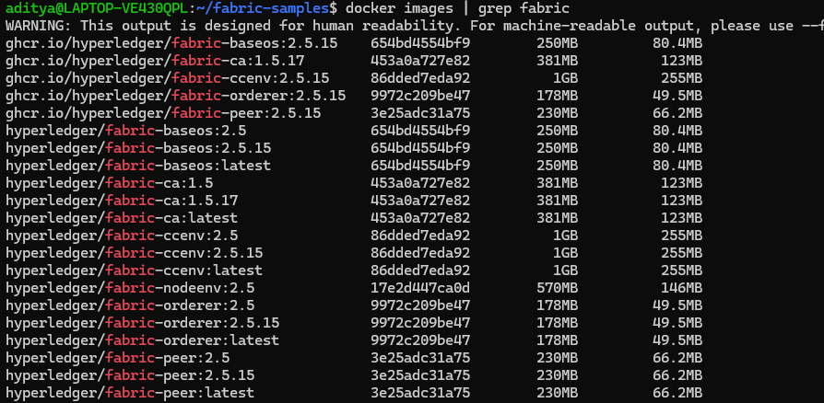

Explain: Confirm hyperledger/fabric-nodeenv:2.5 is in the list. This image is the Node.js build environment that Fabric uses to compile and run JavaScript chaincode inside a container. If it is missing, deployCC will fail with a "No such image" error.

Step 6 — Set PATH and config path

code :
export PATH=$PATH:$HOME/fabric-samples/bin
export FABRIC_CFG_PATH=$HOME/fabric-samples/config

Explain: The peer binary lives in ~/fabric-samples/bin, which is not on your shell's PATH by default. Without this export, the shell cannot find the command and returns "peer not found". FABRIC_CFG_PATH tells the peer CLI where to find core.yaml, the main configuration file. Without it, the peer errors with "cannot init crypto, path does not exist".

code :
peer version

You should see Version: v2.5.15.

Step 7 — Start the network and create the channel

code :

cd ~/fabric-samples/test-network
./network.sh up createChannel
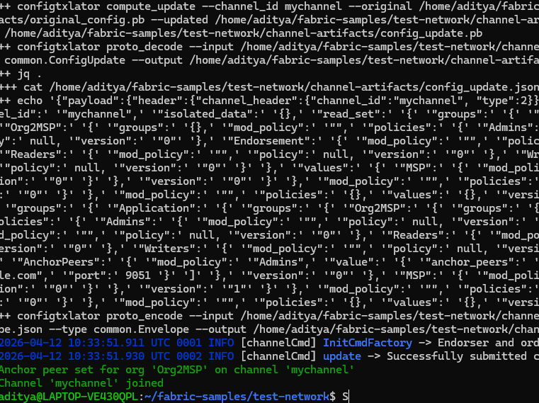

Explain: This single command does everything needed to have a running network with a channel. Internally it uses cryptogen to generate TLS certificates and identity material (MSP) for Org1, Org2, and the Orderer. It starts three Docker containers — orderer.example.com on port 7050, peer0.org1.example.com on port 7051, and peer0.org2.example.com on port 9051. It then
runs configtxgen to create mychannel.block (the channel genesis block), submits it to the orderer, joins both peers to the channel, and sets anchor peers so the two organizations can discover each other via gossip. The default channel name is mychannel.

Step 8 — Deploy the chaincode

code :
./network.sh deployCC \
-ccn basic \
-ccp ../asset-transfer-basic/chaincode-javascript \
-ccl javascript
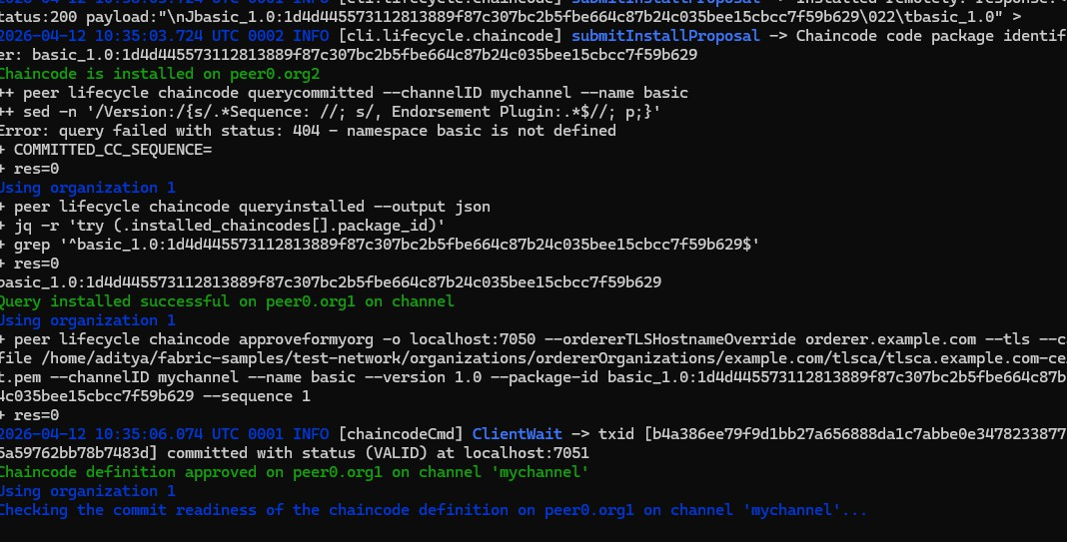

Explain: -ccn basic is the name your chaincode will be called by in all future commands. -ccp is the path to the chaincode source code. -ccl javascript tells Fabric to use the Node.js runtime.
Internally this runs the full Fabric chaincode lifecycle — package the source into a .tar.gz, install it on both peers, have Org1 approve the definition, have Org2 approve the definition (both
approvals are required since majority endorsement is the default policy), and finally commit the definition to the channel. Once committed, two new Docker containers appear — one chaincode container per peer (dev-peer0.org1... and dev-peer0.org2...).

Step 9 — Set peer identity environment variables

code :
export FABRIC_CFG_PATH=$HOME/fabric-samples/config export PATH=$PATH:$HOME/fabric-samples/bin
export CORE_PEER_TLS_ENABLED=true
export CORE_PEER_LOCALMSPID="Org1MSP"
export
CORE_PEER_TLS_ROOTCERT_FILE=$HOME/fabric-samples/test-network/organizations/pee rOrganizations/org1.example.com/peers/peer0.org1.example.com/tls/ca.crt

export
CORE_PEER_MSPCONFIGPATH=$HOME/fabric-samples/test-network/organizations/peerOrg anizations/org1.example.com/users/Admin@org1.example.com/msp
export CORE_PEER_ADDRESS=localhost:7051
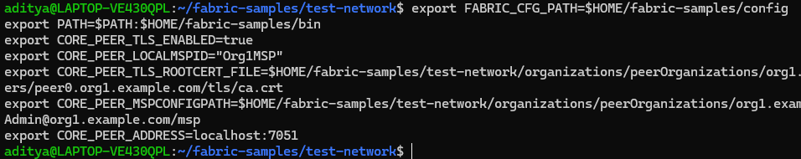

Explain: The peer CLI has no built-in session — it does not know who you are. Every command needs to know which organization's identity to use, which peer to connect to, and how to verify TLS. These five variables provide exactly that. CORE_PEER_LOCALMSPID declares "I am Org1". CORE_PEER_MSPCONFIGPATH points to the Admin user's private signing key and certificate. CORE_PEER_TLS_ROOTCERT_FILE provides the CA certificate to verify the peer's TLS identity. CORE_PEER_ADDRESS is which peer to send requests to. These must be re-exported in every new terminal session.

Step 10 — Initialize the ledger with sample data

code :
peer chaincode invoke \
-o localhost:7050 \
--ordererTLSHostnameOverride orderer.example.com \
--tls \
--cafile
$HOME/fabric-samples/test-network/organizations/ordererOrganizations/example.com/orderers/ orderer.example.com/msp/tlscacerts/tlsca.example.com-cert.pem \
-C mychannel \
-n basic \
--peerAddresses localhost:7051 \
--tlsRootCertFiles
$HOME/fabric-samples/test-network/organizations/peerOrganizations/org1.example.com/peers/ peer0.org1.example.com/tls/ca.crt \
--peerAddresses localhost:9051 \
--tlsRootCertFiles
$HOME/fabric-samples/test-network/organizations/peerOrganizations/org2.example.com/peers/ peer0.org2.example.com/tls/ca.crt \
--waitForEvent \

-c '{"function":"InitLedger","Args":[]}'
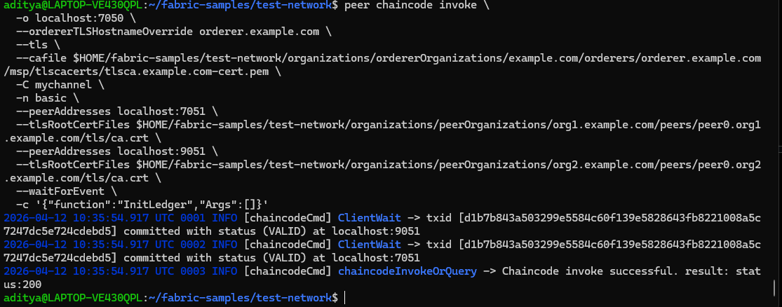

Explain: invoke is used for any operation that writes to the ledger. -o localhost:7050 is the orderer address. --tls and --cafile enable TLS and provide the CA cert to verify the orderer. -C mychannel and -n basic identify which channel and chaincode. The two --peerAddresses and
--tlsRootCertFiles pairs are the critical part — the default endorsement policy requires a majority of organizations to endorse. With two orgs, both must sign. Sending to only one peer results in ENDORSEMENT_POLICY_FAILURE. --waitForEvent blocks until both peers confirm the transaction is committed (status VALID) rather than just submitted. InitLedger seeds the ledger with six sample assets.

Step 11 — Query all assets

code :
peer chaincode query \
-C mychannel \
-n basic \
-c '{"Args":["GetAllAssets"]}'
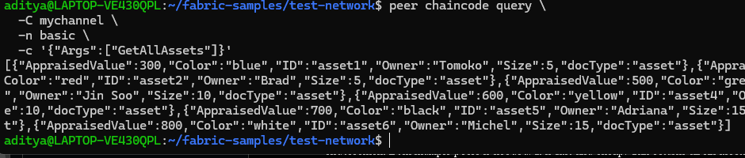

Explain: query is for read-only operations. No transaction is created, no block is written, no endorsement from multiple peers is needed. It is fast and cheap. This returns all six assets seeded by InitLedger:
json [
{"ID":"asset1","Color":"blue","Size":5,"Owner":"Tomoko","AppraisedValue":300},
{"ID":"asset2","Color":"red","Size":5,"Owner":"Brad","AppraisedValue":400},
{"ID":"asset3","Color":"green","Size":10,"Owner":"Jin Soo","AppraisedValue":500},
{"ID":"asset4","Color":"yellow","Size":10,"Owner":"Max","AppraisedValue":600},
{"ID":"asset5","Color":"black","Size":15,"Owner":"Adriana","AppraisedValue":700},
{"ID":"asset6","Color":"white","Size":15,"Owner":"Michel","AppraisedValue":800}
]

Step 12 — Read a specific asset

code :
peer chaincode query \
-C mychannel \
-n basic \
-c '{"Args":["ReadAsset","asset5"]}'
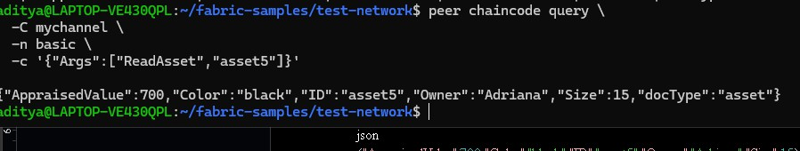

Result:

json
{"AppraisedValue":700,"Color":"black","ID":"asset5","Owner":"Adriana","Size":15}

Explain: ReadAsset takes an asset ID and returns that single asset's data from the world state. The world state is a key-value database that stores the current (latest) value for each asset. The full transaction history is stored in the blockchain, but queries read from this faster world state.

Step 13 — Create a new asset

code :
peer chaincode invoke \

-o localhost:7050 \
--ordererTLSHostnameOverride orderer.example.com \
--tls \
--cafile
$HOME/fabric-samples/test-network/organizations/ordererOrganizations/example.com/orderers/ orderer.example.com/msp/tlscacerts/tlsca.example.com-cert.pem \
-C mychannel \
-n basic \
--peerAddresses localhost:7051 \
--tlsRootCertFiles
$HOME/fabric-samples/test-network/organizations/peerOrganizations/org1.example.com/peers/ peer0.org1.example.com/tls/ca.crt \
--peerAddresses localhost:9051 \
--tlsRootCertFiles
$HOME/fabric-samples/test-network/organizations/peerOrganizations/org2.example.com/peers/ peer0.org2.example.com/tls/ca.crt \
--waitForEvent \
-c '{"function":"CreateAsset","Args":["asset10","blue","10","Pranav","1000"]}'

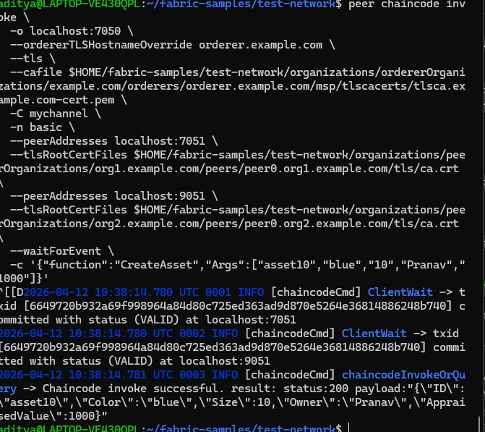

Explain: CreateAsset takes five arguments in order — [ID, Color, Size, Owner,
AppraisedValue]. This is a write operation so both peers must endorse. The orderer packages the endorsed transaction into a block and delivers it to both peers. Both confirm VALID and the asset is permanently recorded on the ledger.

code :
peer chaincode query -C mychannel -n basic -c '{"Args":["ReadAsset","asset10"]}'
# {"AppraisedValue":1000,"Color":"blue","ID":"asset10","Owner":"Pranav","Size":10}

The transaction flow showing what happens inside Fabric every time you run invoke or query

Shows what happens inside Fabric every time you run peer chaincode invoke — the proposal, endorsement, ordering, and commit flow — and why both peers are always required for any write operation.
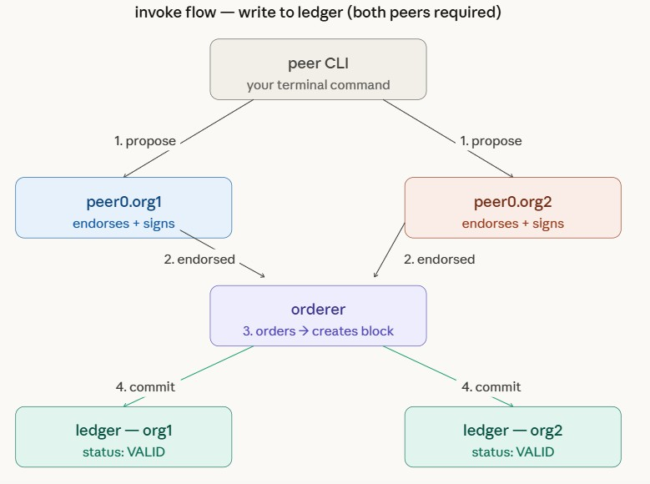

Step 14 — Transfer asset ownership

code :
peer chaincode invoke \
-o localhost:7050 \
--ordererTLSHostnameOverride orderer.example.com \
--tls \
--cafile
$HOME/fabric-samples/test-network/organizations/ordererOrganizations/example.com/orderers/ orderer.example.com/msp/tlscacerts/tlsca.example.com-cert.pem \
-C mychannel \
-n basic \
--peerAddresses localhost:7051 \
--tlsRootCertFiles
$HOME/fabric-samples/test-network/organizations/peerOrganizations/org1.example.com/peers/ peer0.org1.example.com/tls/ca.crt \

--peerAddresses localhost:9051 \
--tlsRootCertFiles
$HOME/fabric-samples/test-network/organizations/peerOrganizations/org2.example.com/peers/ peer0.org2.example.com/tls/ca.crt \
--waitForEvent \
-c '{"function":"TransferAsset","Args":["asset10","Rahul"]}'
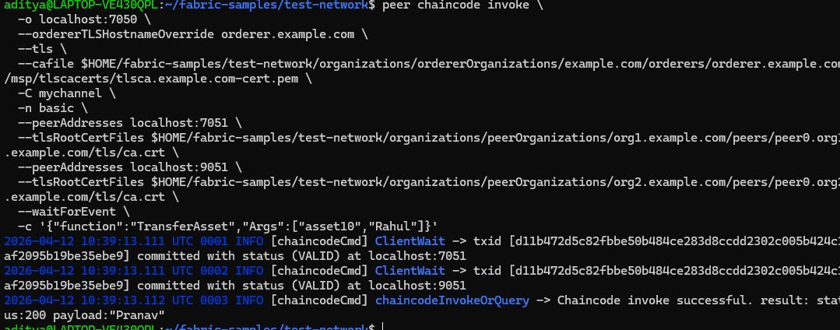

Explain: TransferAsset takes [assetID, newOwner]. It reads the current asset from the world state, updates the Owner field, and writes it back. The function returns the previous owner
("Pranav") as confirmation. Both peers endorse, the orderer commits the block, and the ledger is updated permanently.
Verify the ownership change:

code :
peer chaincode query -C mychannel -n basic -c '{"Args":["ReadAsset","asset10"]}'
# {"AppraisedValue":1000,"Color":"blue","ID":"asset10","Owner":"Rahul","Size":10}

Owner is now Rahul

Step 15 — To stop/bring down the Hyperledger Fabric network, run:
./network.sh down

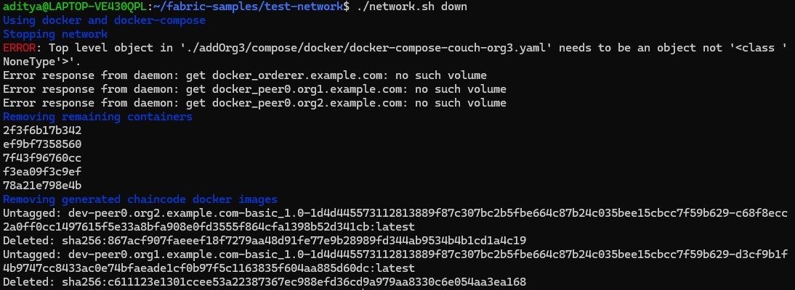

Network architecture showing all components and how they relate
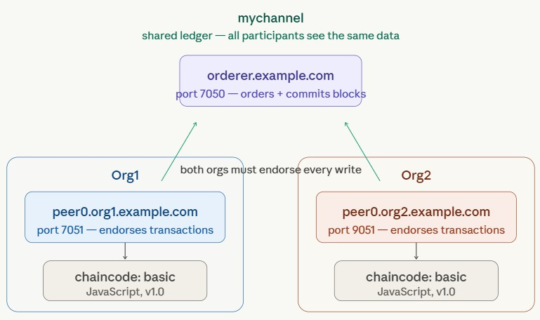

Conclusion:
This experiment demonstrated how blockchain networks work using Hyperledger Fabric and how transactions are securely executed. The experiment also helped in understanding real-time asset management using smart contracts.

